15.) ls -f
This command is used to show all the file in the current directories
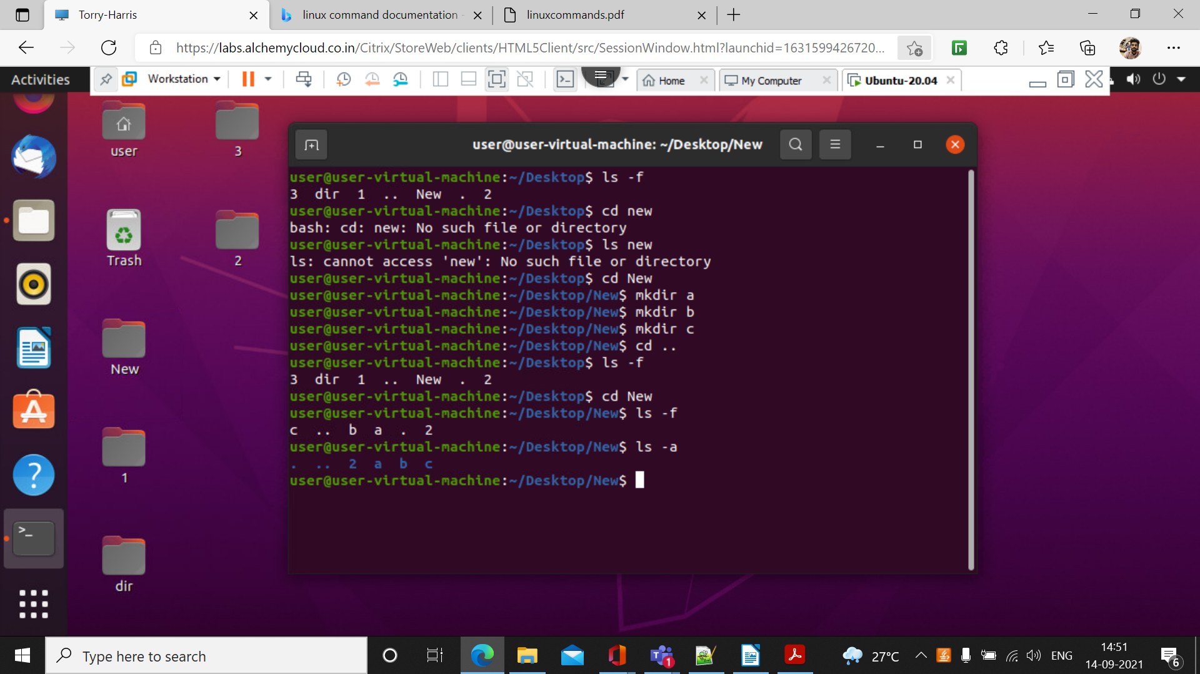

16.)who
It display the user currently logged in
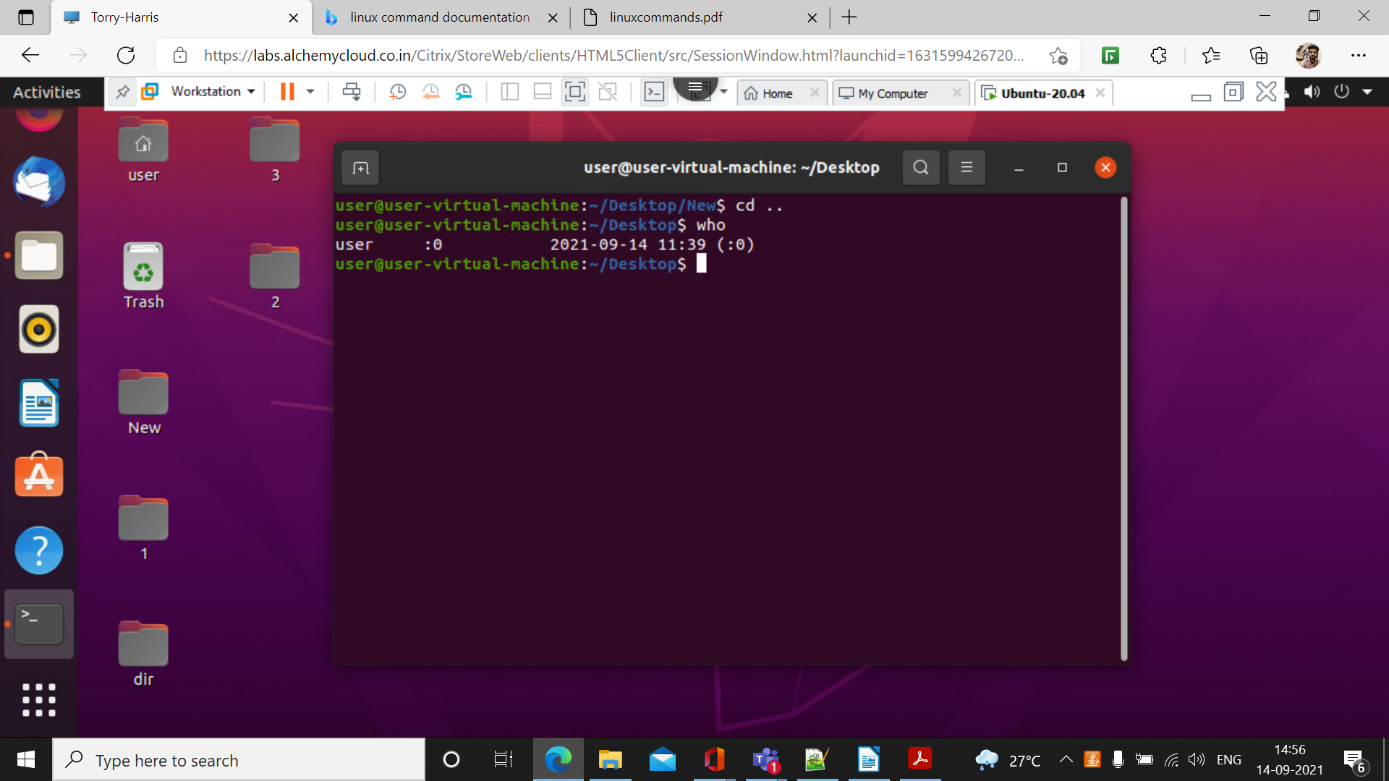

17.)Date

It Display the date and time
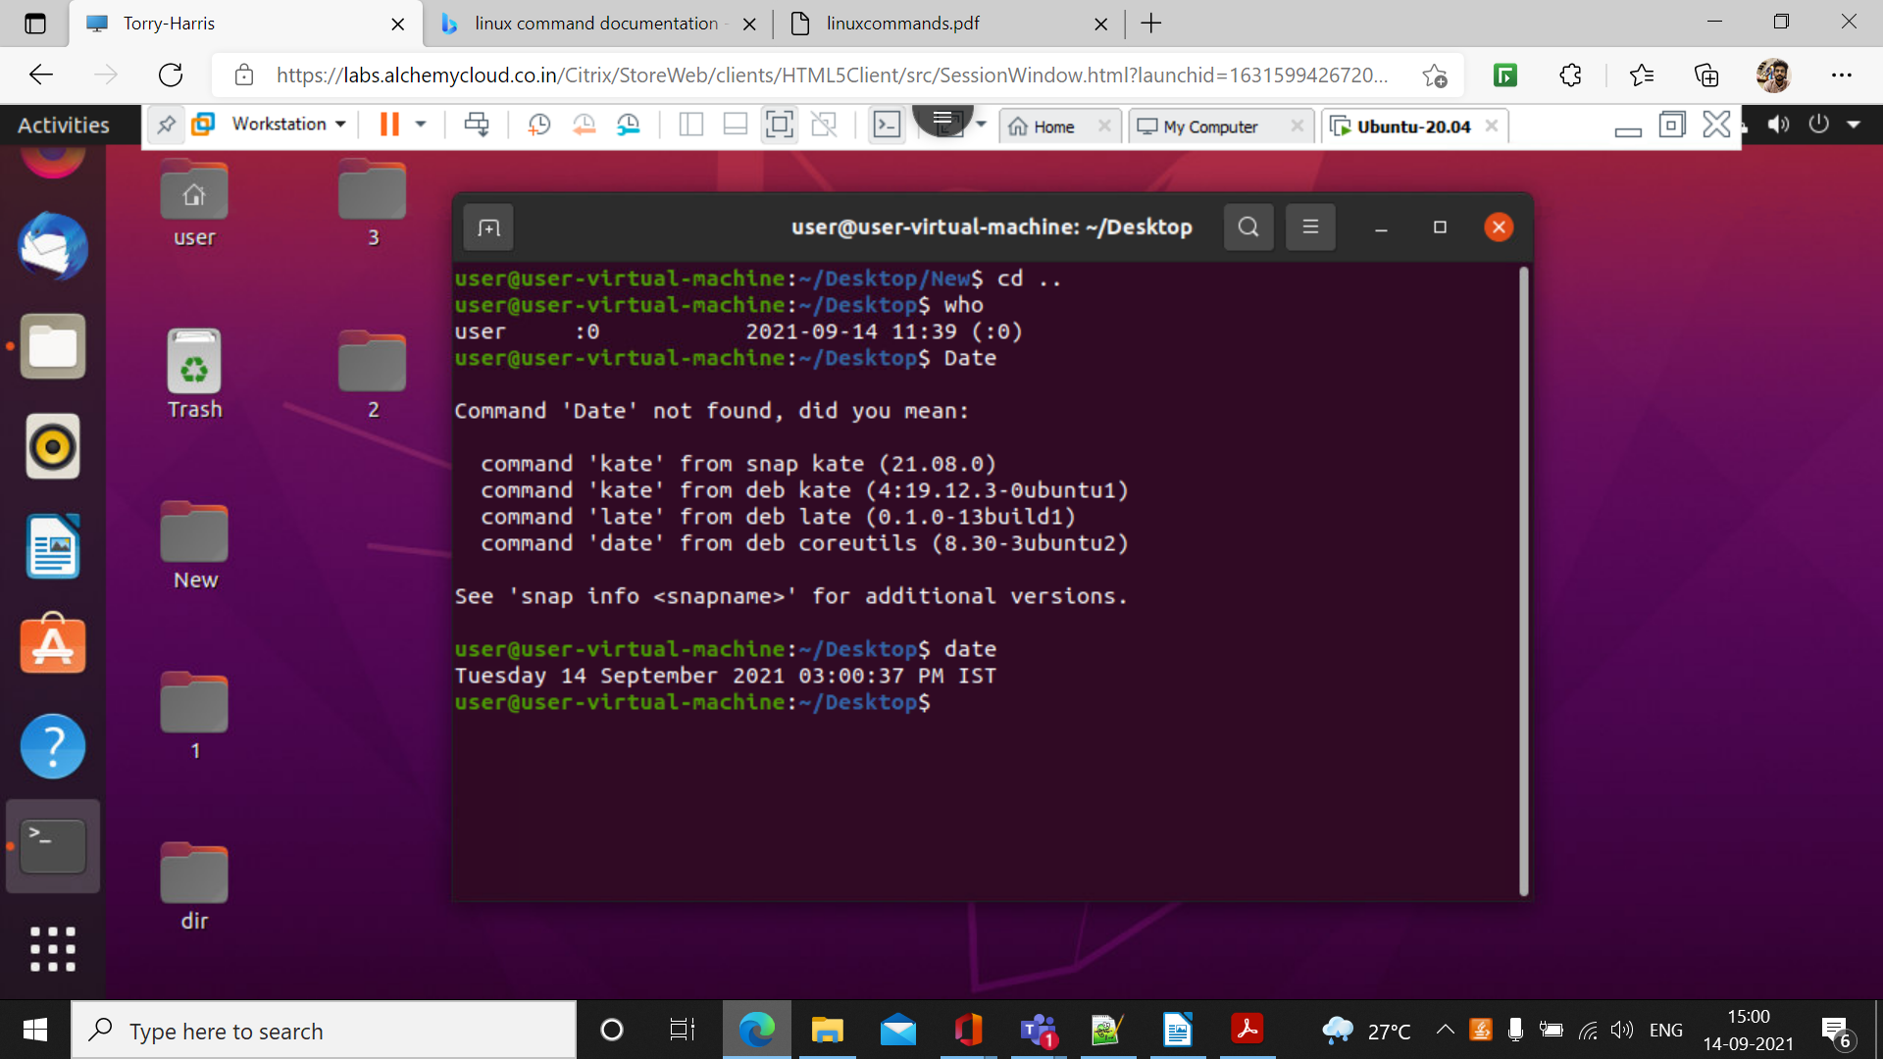

18.)touch
This command is used to create a new file
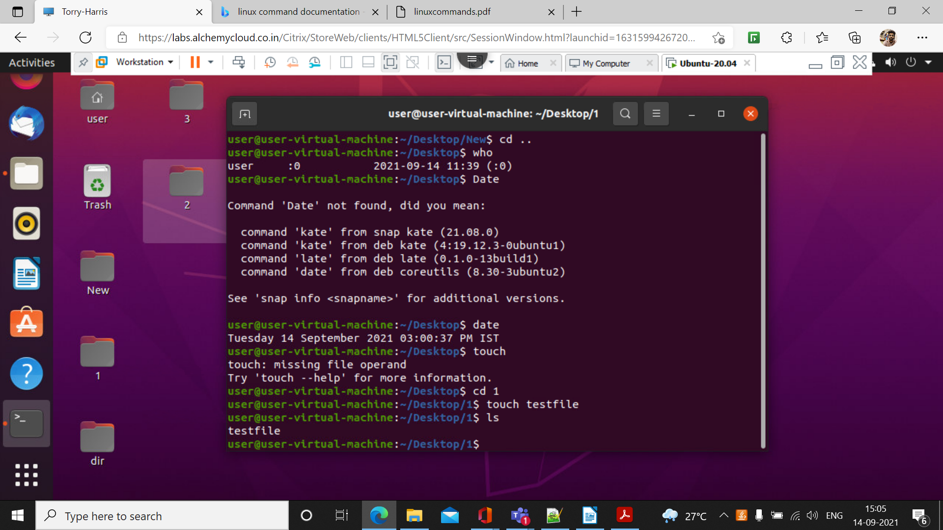

19.) clear
This command is used to clear all the work in the current terminal
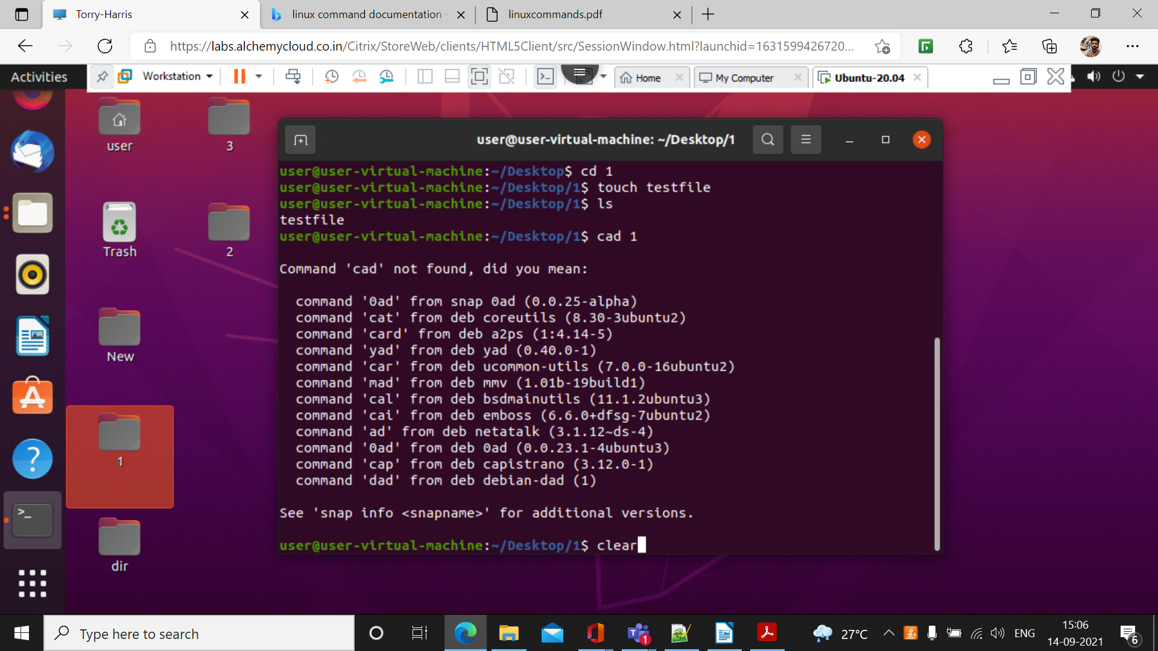

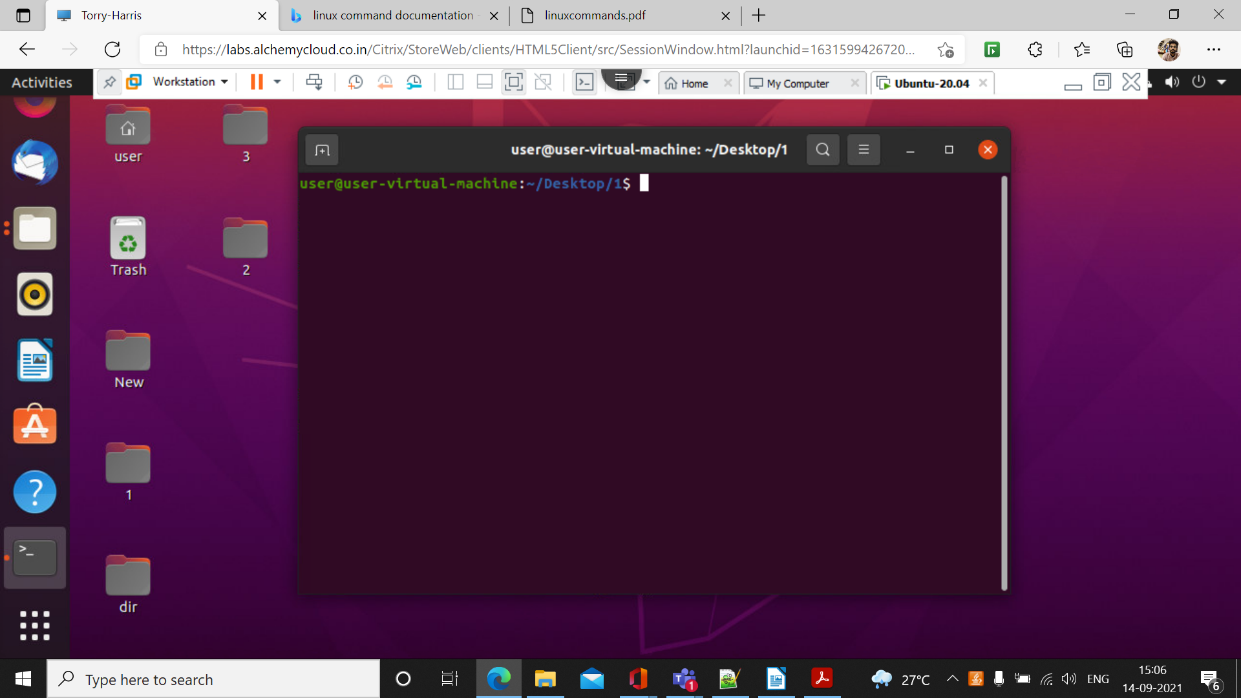

20.) cad
cad command is used to read the text file
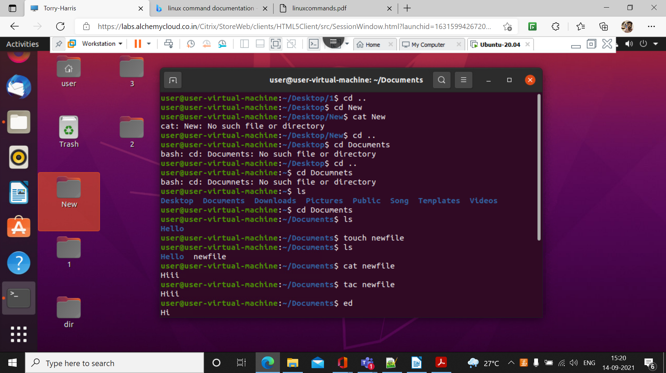

21.)tac
This command is reverse of cat command it displays the result in reverse order.
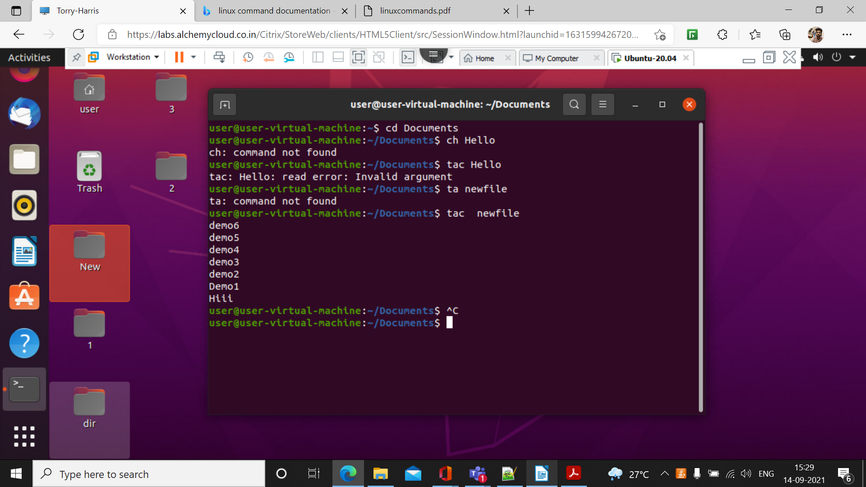

22.)rm
rm command is used to remove the file
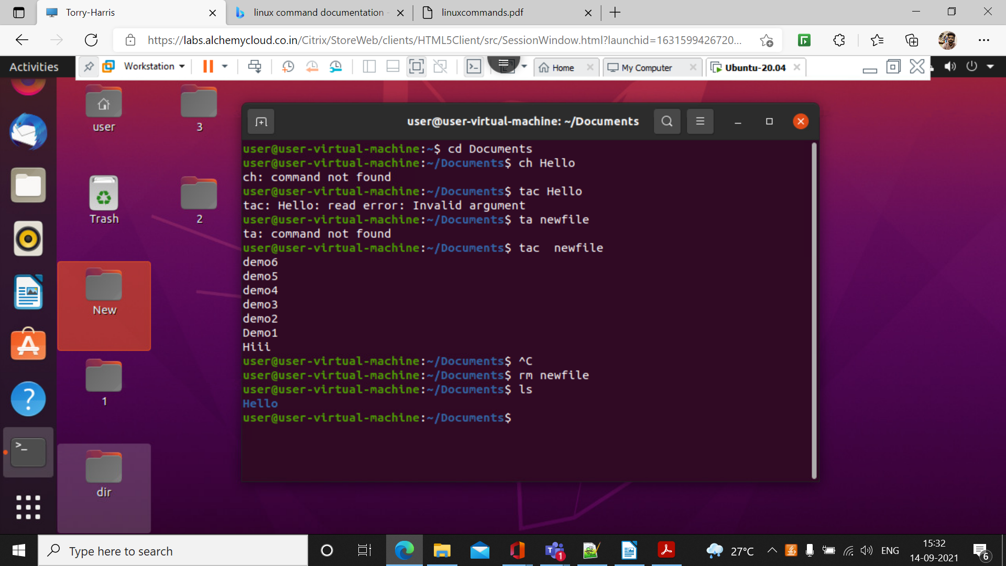

23.)cp
cp command is used to copy the file from one destination to other
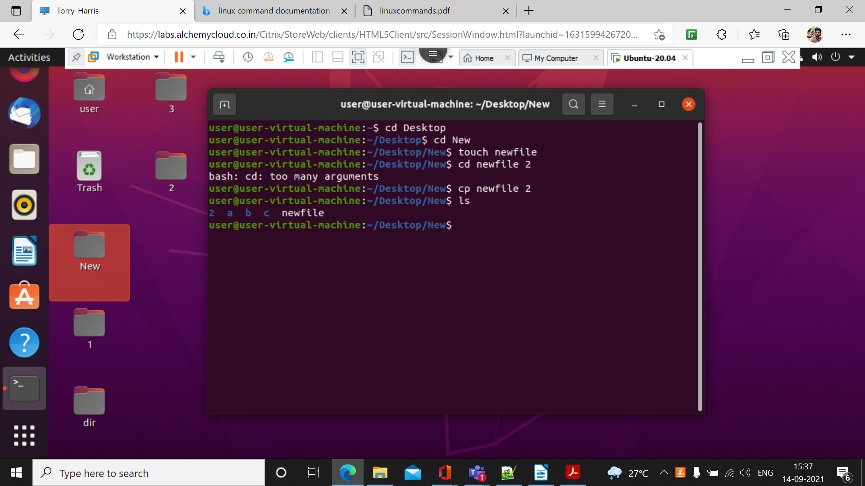

24.) mv
mv command is used to move the file from one directories to another directories

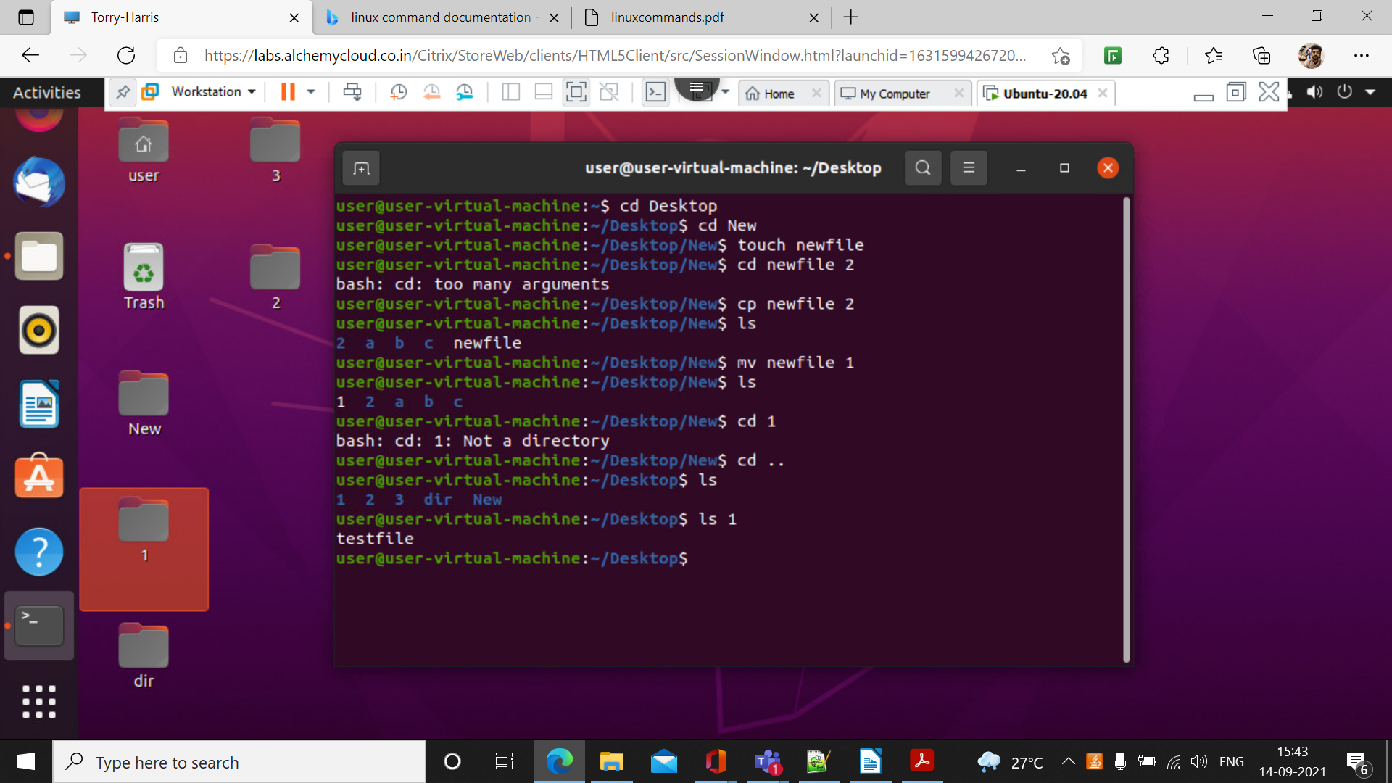

25.) sort
sort command is used to sort the text file

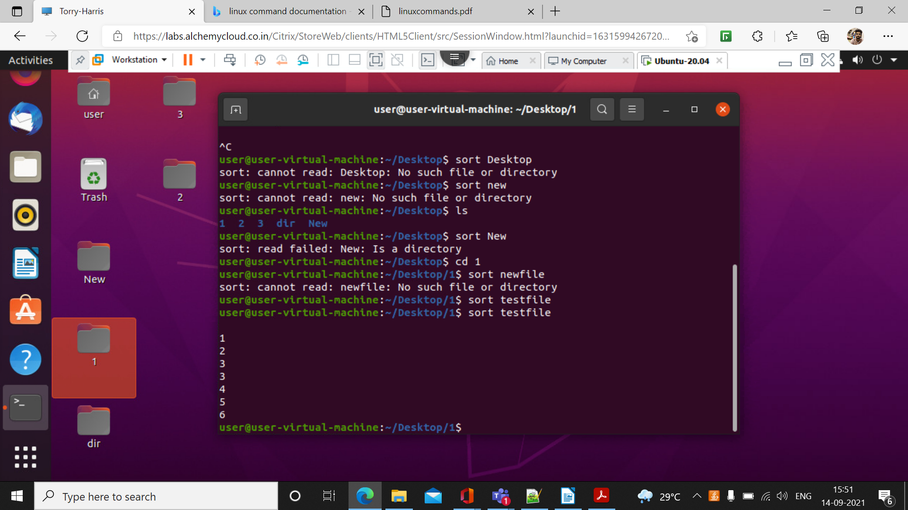

\

26.) tree
It displays the tree for the current directories
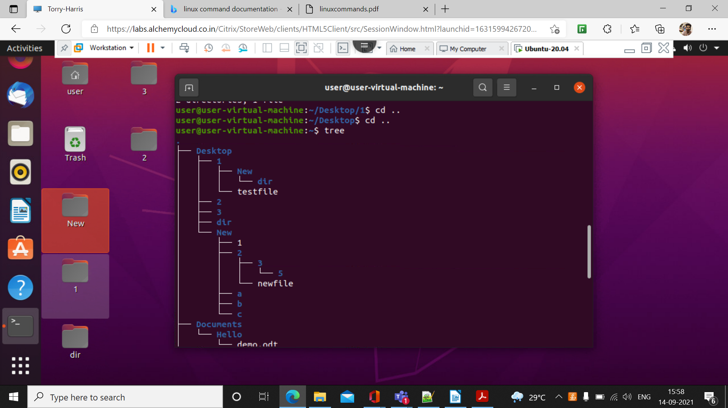

27.)sudo apt
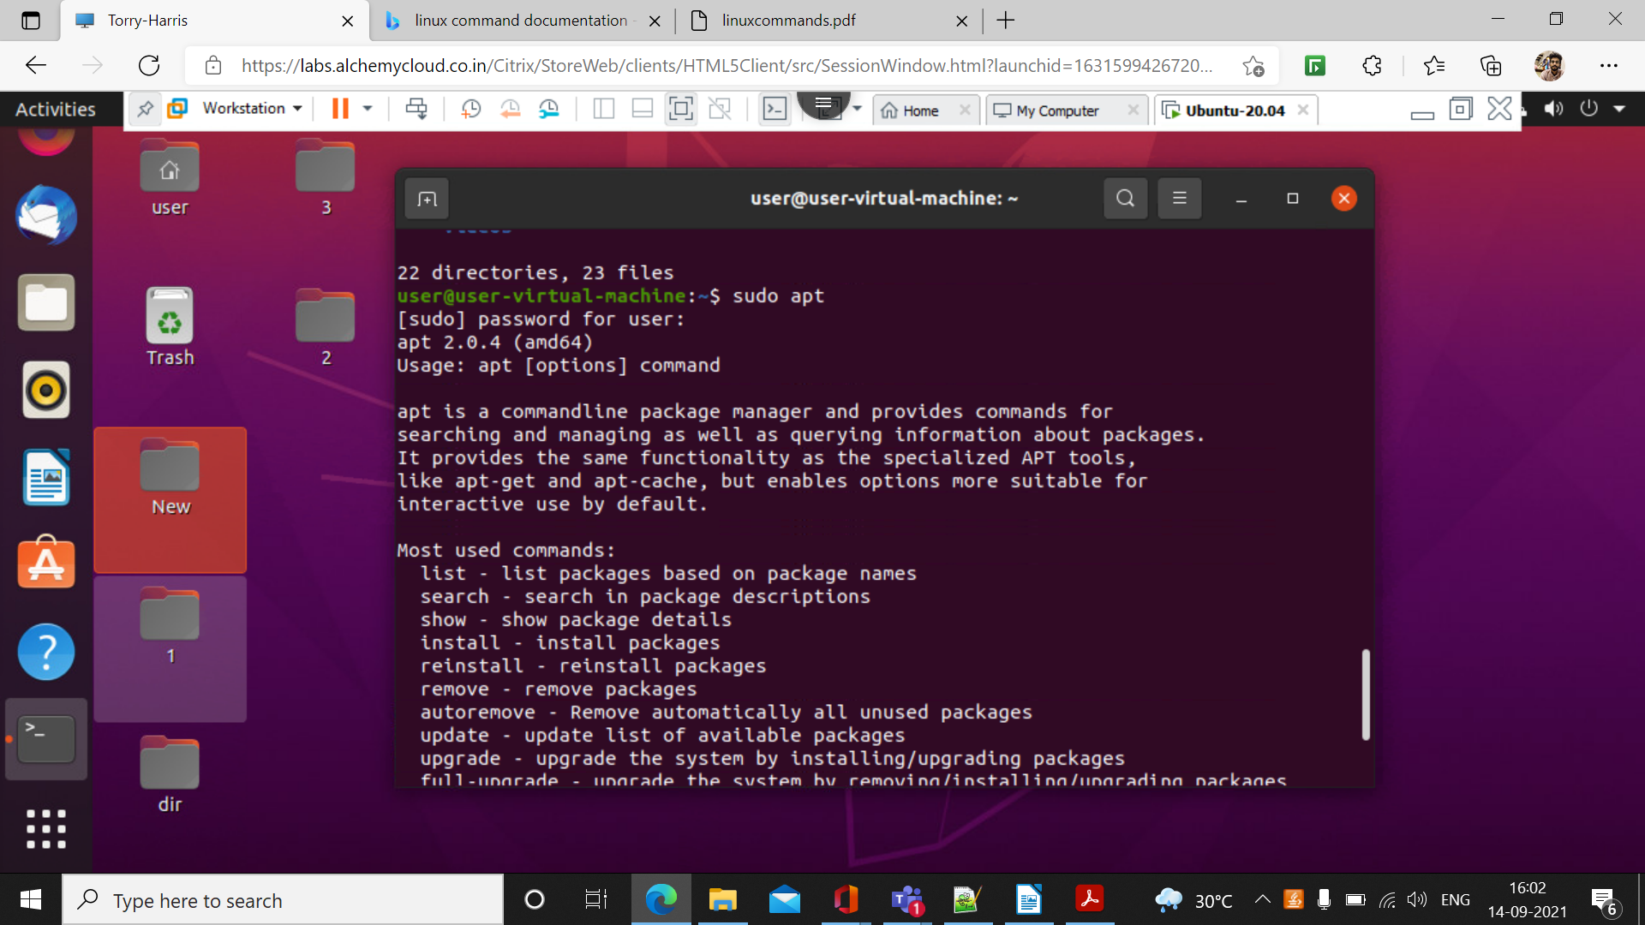

28.)ls -lr
It is used to display the content inside the file in data format order
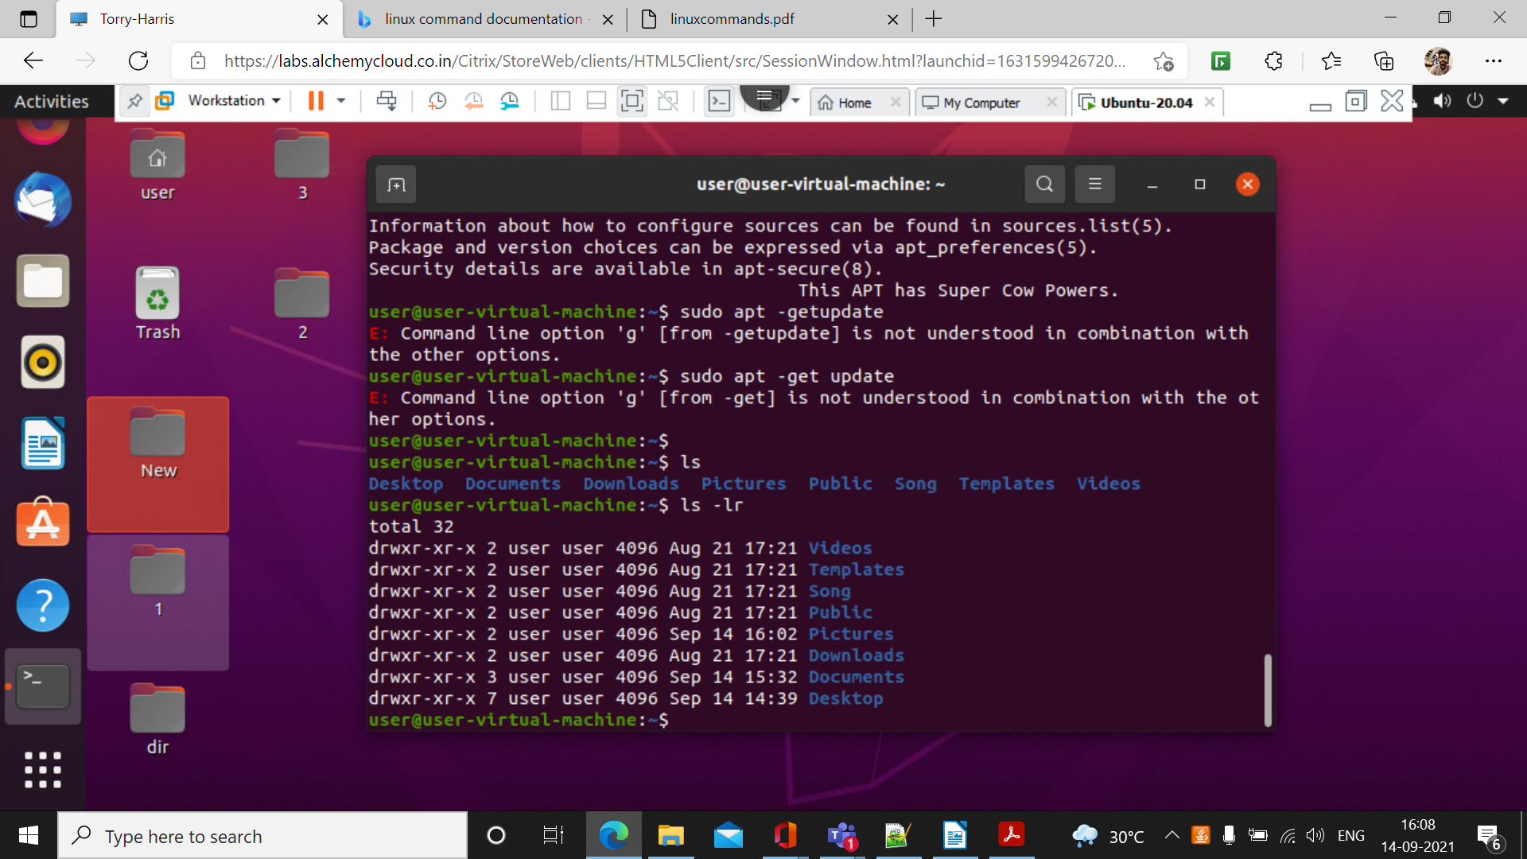

29.) ls – lr -a
It display the content inside the file in a recursive order including the hidden file
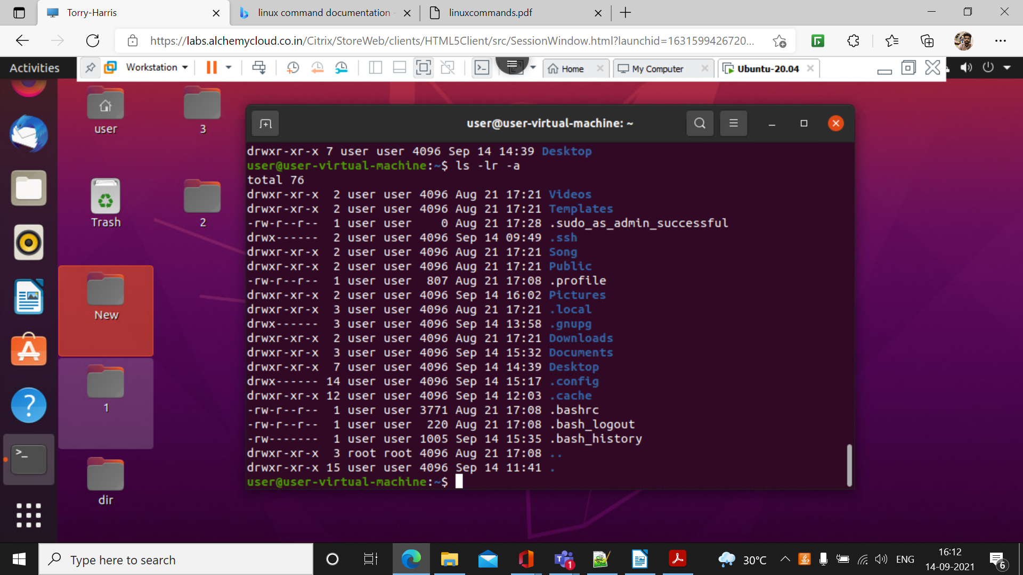

30.)mkdir -p 1/2/3/4/5
This command is used to create one directory inside another directory
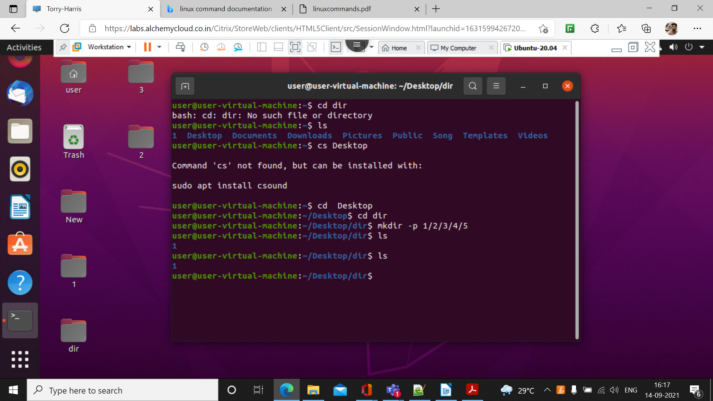

31.)mkdir demo{1,2,3}
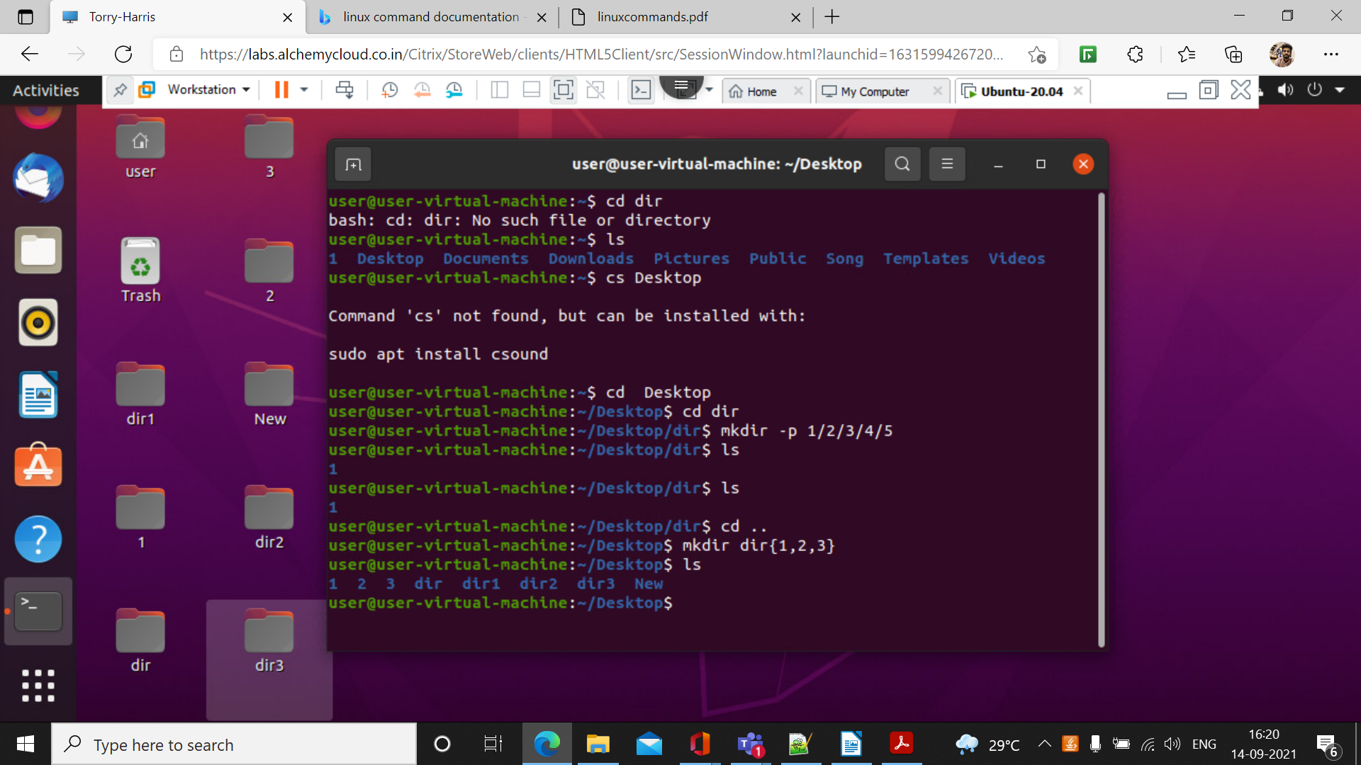

32.)rm -rf 2
This command is used to remove the directory
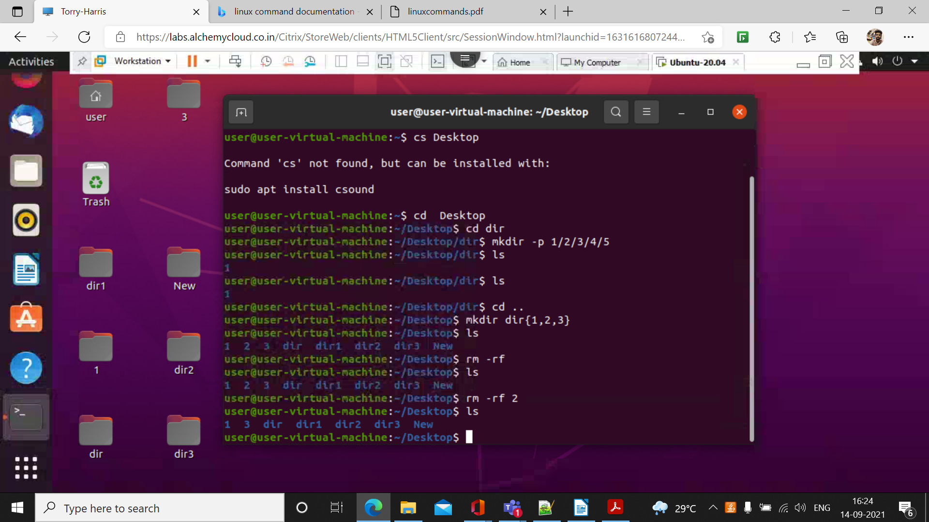

33.) passwd
password command is used to change the password for the system
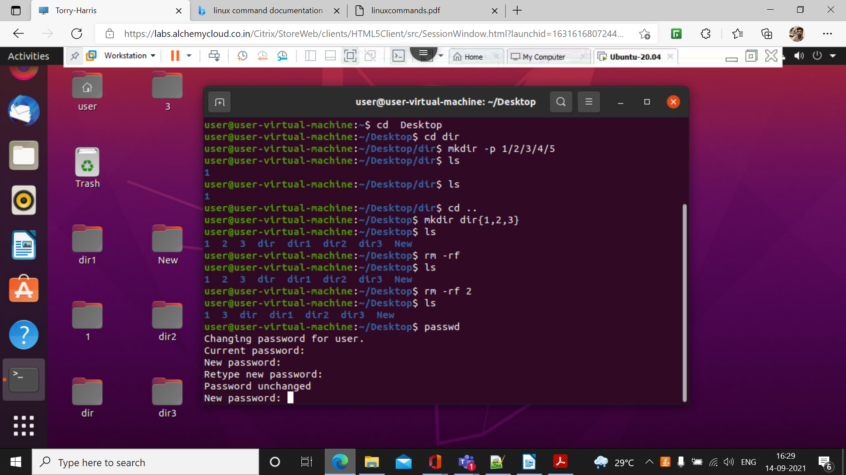

34 tree -c
This command is used to display the hierarchy view of directory
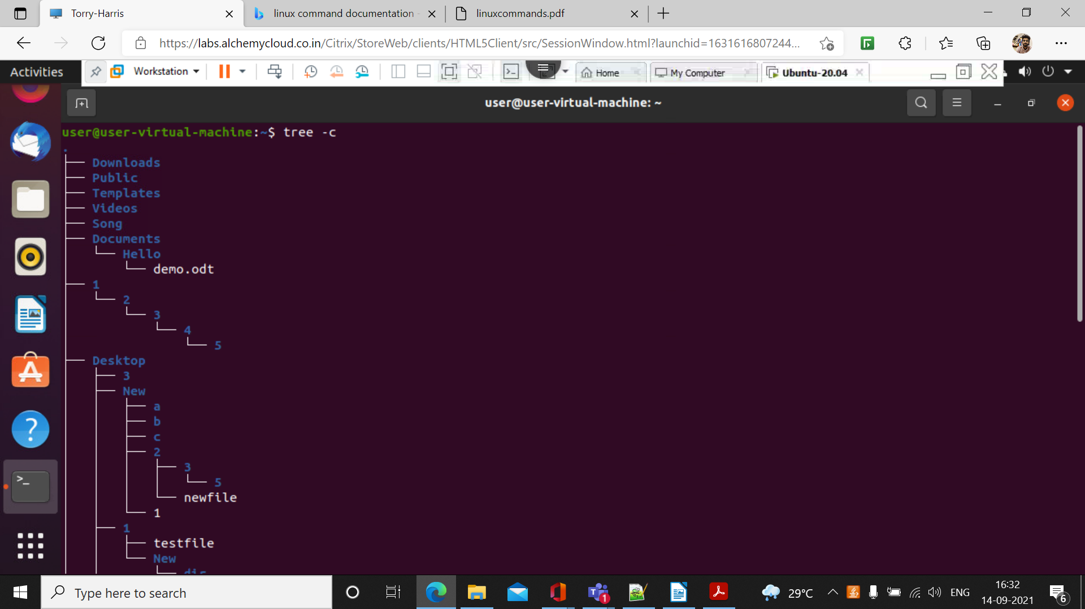

35.)help

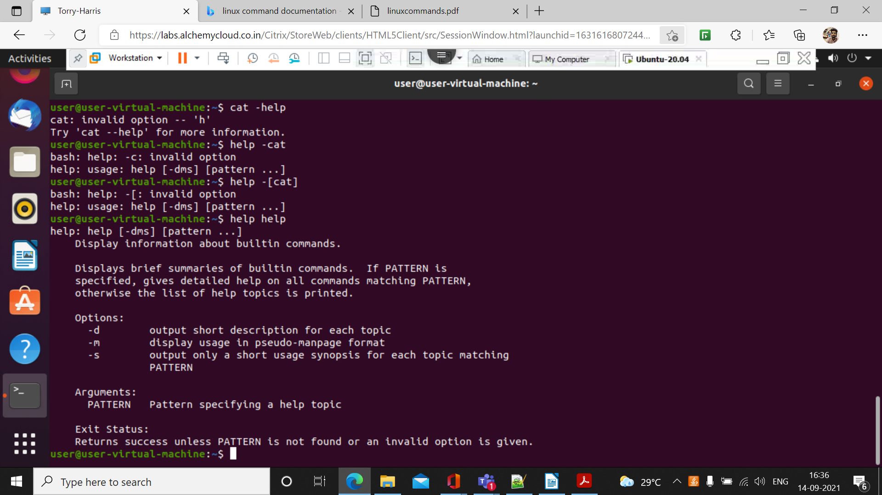

36.) -b
This command is used to display the line number inside a text file


